
OUR PUBLICATIONS
The Tonfa: An Extension of the Mind and Body (BETA / VHS)
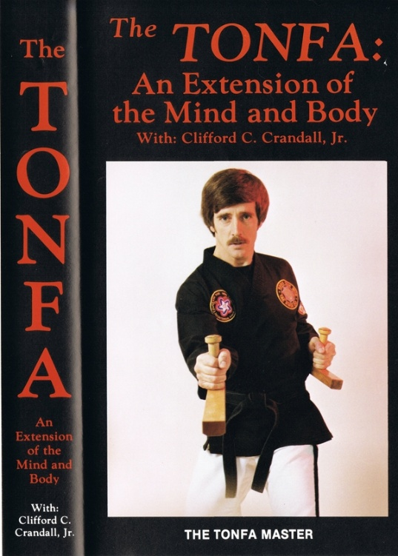
OUT OF PRINT. In 1984, Grandmaster Crandall had the opportunity to train in Japan under Master Seikichi Toguchi where he studied tonfa. When he returned from training in Japan he retired from the State of New York educational system where he had been a Superintendent of Schools, principal, and classroom teacher, to teach martial arts full time. He formed Tonfa Master Enterprises, which produced instructional martial arts videos, books, and materials.
In 1985, he released The Tonfa: An Extension of the Mind and Body on BETA and VHS, which was distributed by Century Martial Arts and other suppliers.
This video documented the single tonfa kata, Yom Chi, developed by Grandmaster Crandall. This video was unique a few ways for time. First, tonfa forms are traditionally executed using a pair of tonfa, and Yom Chi is a single-tonfa form. This made it an ideal training format for law enforcement agencies using the PR-24. Grandmaster Crandall was also a Law Enforcement Defensive Tactics instructor, teaching the use of the tonfa (or PR-24). Second, it included slow motion sequences of the form and movements. The video also included blocks, strikes, and other segments. It concluded with a brief sequence in the dark with “electric tonfas”, a pair of custom made tonfa with built in colored lights. The following year, in 1986, Vantage Press, Inc., New York City released "The Tonfa: An Extension of the Mind and Body”, and its release resulted in Grandmaster Crandall being a guest speaker on a number of radio and T.V. shows.
For more information visit AMAI-EagleStyle.com.
Copyright American Martial Arts Institute. All rights reserved.
May be available in additional formats.



