
OUR PUBLICATIONS
The Tonfa: An Extension of the Mind and Body (BOOK)
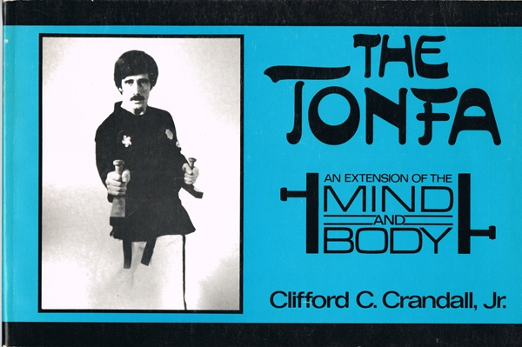
OUT OF PRINT. First Printing: Vantage Press, Inc., New York City released "The Tonfa: An Extension of the Mind and Body” in 1986. The first edition was a landscape orientation book, and its release resulted in Grandmaster Crandall being a guest speaker on a number of radio and T.V. shows. The second printing was re-edited into a more traditional portrait-orientation format. This book was the first to document a single-tonfa kata developed by Grandmaster Crandall called Yom Chi. In addition to the form, the book includes a brief history of the tonfa, fundamental blocks and strikes, and a series of scenarios against other weapons. This book followed the release of the instructional video by the same name, which was released on BETA and VHS formats in 1985, and distributed by Tonfa Master Enterprises. The success of these two resources resulted in Grandmaster Crandall hosting and producing the Martial Arts Today Show, which first aired in 1987 and ran for 11 years on NBC affiliates. It also led to Tonfa Master Enterprises releasing subsequent productions including a line of custom made Tonfa and Naginata. In 1995, the book was updated with new cover and some new photographs.
For more information visit AMAI-EagleStyle.com.
Copyright American Martial Arts Institute. All rights reserved.


