
OUR PUBLICATIONS
Women’s Self Defense
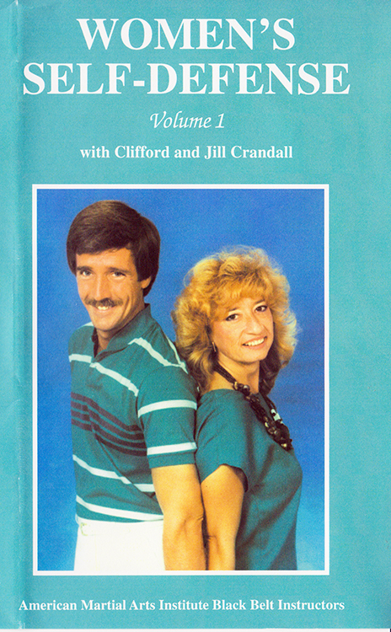
OUT OF PRINT. In 1988, Tonfa Master Enterprises released Women’s Self-Defense, Volume 1. Produced by Grandmaster Crandall and co-instructed with Jill Crandall, this one-hour VHS was a pioneer in self-defense for women.
One of the unique features was its emphasis on awareness and avoidance with segments depicting common set-ups and scams. This was followed by self-defense techniques for a variety of assault scenarios.
The later Master Jill Crandall passed away in 2002, and was also the instructor of the VHS The Naginata at its Best, an occasional co-host of the Martial Arts Today Show, a top tournament competitor, especially with the naginata, in the 1980s and 90s, and a member of the China-America Team to perform in the People’s Republic of China by Government invitation.
This VHS went out of production with the popularity of the DVD format in the late 1990’s, but it paved the way for later publications which expanded upon the foundation it laid. This included the women’s self-defense chapter in Be Safe Physically and Mentally with Crandall System. This, in turn, was further expanded into the full-length book Women’s Self-Defense and Awareness in a Changing World by Master Lynn Jessee and Grandmaster Crandall, and in the two-hour instructional DVD titled Self-Defense Techniques and Awareness in a Changing World by Master Gisella Stalloch and Grandmaster Crandall. Today, the American Martial Arts Institute continues to offer seminars for Women’s Self-Defense and other groups. For the most recent publications or seminar offerings, visit AMAI-EagleStyle.com.
For more information visit AMAI-EagleStyle.com.
Copyright American Martial Arts Institute. All rights reserved.
OUT OF PRINT
