
OUR PUBLICATIONS
The Passing of the Sword (VHS)
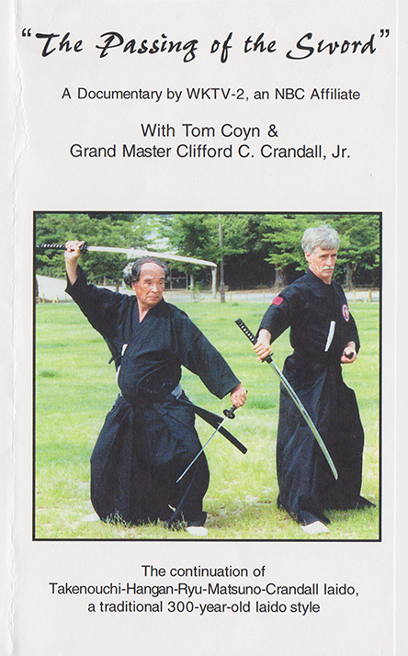
OUT OF PRINT. In 2002, Headmaster Tsuneyoshi Matsuno recognized his long-time iaido student Clifford C. Crandall, Jr. as his successor to Takenouchi-Hangan-Ryu-Matsuno and as the Headmaster of Takenouchi-Hangan-Ryu-Matsuno-Crandall in a ceremony in Akashi, Japan. Headmaster Matsuno passed away in 2005, but had chosen to retire from iaido students. Headmaster Crandall’s certificate of position and succession hangs in the main office training hall of the American Martial Arts Institute.
In addition to this historic ceremony, Grandmaster Crandall led a group of iaido students to train in Japan with Headmaster Matsuno.

Grandmaster Crandall was the coach of the New York State Iaido Team representing New York State in Japan and Director of the “American-Japanese Good Will Tour 2002" to Japan. New York State Legislative Resolution #5333 was adopted in the Senate on May 7, 2002, as well as a as well as a Senatorial Citation being issued on June 30, 2002, both in honour of the positive international relations that Cliff Crandall and his martial arts team had established in their Japanese exchange.
In 2003, WKTV-NBC produced and aired a 30-minute special television program entitled, “The Passing of the Sword.” In 2004, commercials were removed and the program was released on VHS as a 26-minute video documenting the trip, training, and promotion. Copies were donated to libraries across New York State and the United States.
For more information visit AMAI-EagleStyle.com.
Copyright American Martial Arts Institute. All rights reserved.
May be available in additional formats.
